**Pedro’s Journey: National Youth Day Mobile Game Application**

A Capstone Project

Presented to the Faculty of the

Department of Computer and Information Sciences

University of San Carlos

In Partial Fulfillment

of the Requirements for the Degree

BACHELOR OF SCIENCE IN INFORMATION TECHNOLOGY

By

BRYAN Z. BISPO

PENUEL B. CALLE

NICOLAS ANDRE P. FERRAREN

KITT MICHAEL EDWARD P. YAP

ANGIE M. CENIZA, PhD

Faculty Adviser

November 2018

**CERTIFICATE OF OWNERSHIP/ORIGINALITY**

This is to certify that the authors are responsible for the work submitted in this capstone. The intellectual content of this capstone is a product of original work. Any assistance that the authors received in the preparation and work of the capstone itself has been acknowledged. In addition, the authors certify that the materials and literatures taken from other sources are properly quoted.

Bispo, Bryan Z.

Calle, Penuel B.

Ferraren, Nicolas Andre P.

Yap, Kitt Michael Edward P.

**APPROVAL SHEET**

This capstone entitled, “**PEDRO’S JOURNEY: NATIONAL YOUTH DAY MOBILE GAME APPLICATION**” prepared and submitted by **BISPO, CALLE, FERRAREN, AND YAP** in partial fulfillment for the degree of **BACHELOR OF SCIENCE IN INFORMATION TECHNOLOGY**, has been examined and is recommended for acceptance and approval for ORAL EXAMINATION

**CAPSTONE COMMITTEE**

ANGIE M. CENIZA, PhD

Adviser

CHRISTINE F. PEÑA, M. Math ELMO B. RANOLO

Member Member

CHRISTIAN V. MADERAZO, M. Eng.

Committee Chair

**PANEL OF EXAMINERS**

Approved by the Committee on Oral Examination with a grade of **PASSED.**

CHRISTINE F. PEÑA, M. Math ELMO B. RANOLO

Member Member

CHRISTIAN V. MADERAZO, M. Eng.

Committee Chair

Accepted and approved in partial fulfillment of the requirements for the degree **BACHELOR OF SCIENCE IN INFORMATION TECHNOLOGY.**

CHRISTIAN V. MADERAZO, M. Eng.

Chair, Department of Computer and Information Sciences

November 17, 2018

Date of Oral Examination

**ABSTRACT**

This research was done to further improve the people’s National Youth Day experience and made it a unifying, fun, and engaging experience for everyone participating. Since the participants of National Youth Day predominantly consisted of the youth from ages 16 to 39, the researchers aimed to create an application that is educational yet fun and immersive at the same time. This was to echo the specific contemporary characteristic of wanting to have fun that all the youths share so that they will have a more unifying, engaging, and spiritual progress. This research also furthered the people’s understanding of the historical and religious places and events that had transpired here in Cebu to further their spiritual camaraderie and unity with one another. This research aimed to create such an impact to the people that participated.

**TABLE OF CONTENTS**

**CERTIFICATE OF OWNERSHIP/ORIGINALITY …………………....ii**

**APPROVAL SHEET …………………....iii**

**ABSTRACT …………………....iv**

**TABLE OF CONTENTS …………………....v**

**LIST OF FIGURES …………………....vi**

**LIST OF TABLES …………………….v**

**CHAPTER 1 INTRODUCTION ………………….....1**

**1.1 Rationale of the Study ………………….....1**

**1.2 Statement of the Problem ………………….....2**

**1.2.1 General Objective ………………….....2**

**1.2.2 Specific Objectives ………………….....2**

**1.3 Significance of the Study ………………….....2**

**1.4 Scope and Limitations ………………….....3**

**CHAPTER 2 RELATED SYSTEMS ………………….....5**

**CHAPTER 3 TECHNICAL BACKGROUND ………………….....8**

**CHAPTER 4 DESIGN AND METHODOLOGY …………………...10**

**4.1 Conceptual Framework …………………...10**

**4.2 Analysis and Design …………………...11**

**4.3 Development Method …………………...12**

**4.4 Development Approach …………………...13**

**4.5 Software Development Tools …………………...14**

**4.6 Project Management …………………...15**

**4.6.1 Schedule and Timeline …………………...15**

**4.6.2 Responsibilities …………………...15**

**4.6.3 Budget and Cost Management …………………...16**

**4.7 Verification, Validation, and Testing …………………...16**

**BIBLIOGRAPHY …………………...18**

**APPENDIX**

**Appendix A Transmittal Letter**

**Appendix B Interview Guide**

**Appendix C Software Requirements Specifications**

**Appendix D Functional Requirements**

**Appendix E User Acceptance Testing**

**Appendix F Black Box Test Cases**

**CURRICULUM VITAE**

vi

**LIST OF FIGURES**

**Figure 1. Conceptual Framework …………………...10**

**Figure 2. Use Case Diagram …………………...11**

**Figure 3. Incremental Model …………………...12**

**Figure 4. Bottom-up Approach …………………...13**

vii

**LIST OF TABLES**

**Table 1. Related Game Applications …………………….7**

**Table 2. Software Development Tools …………………...14**

**Table 3. Schedule and Timeline …………………...15**

**Table 4. Responsibilities …………………...15**

**Table 5. Budget and Cost Management …………………...16**

**Table 6. Validation Analysis Table …………………...19**

**Table 7. Verification Analysis Table …………………...20**

vii

**CHAPTER 1**

**INTRODUCTION**

**1.1 Rationale of the Study**

In today’s technological world, people forgot their own roots and the history on how their homeland came to existence. They needed to realize that in order to learn from past mistakes, they must understand their own history.

Technology was to blame for the modern people’s lack of historical knowledge, but the real problem is not the non-utilization of such technology to enhance their learning experience. The National Youth Day, which will be conducted in Cebu Province in 2019, is a way for the youth, called Pilgrims, to be learned the country’s history and religion, more specifically, the history of Cebu Province.

Smartphones and other technological peripherals are common and a necessity in this day and age, the researchers used this norm to develop a game application that taught the participants about the history of Cebu Province. Their aim was to make this purpose as fun and engaging as possible.

Catholicism has been around since the Spanish Colonial period and has a long history, and with it being learned by people can either be fun or boring, depending on the person. One of the most fun, engaging, and effective ways of learning was through playing a game because through this medium, people will be entertained and will be driven to learn more because they find it fun.

According to a study found by Sharon K. who researched how companies train their employees, game-based learning has higher retention rates than traditional learning.  A study at Indiana University stated that game-based learning increased retention by more than 300% in immediate post-testing, and by as much as 10 times when subjects were tested 6 weeks later. It also helped that competition encouraged the users to strive to learn more in order to be on the top scores against other users.

The main goal of this E-learning game application was to teach Pilgrims that participated on National Youth Day the history of Cebu through an educational gaming platform.

**1.2 Statement of the Problem**

**1.2.1 General Objective**

The research developed an RPG application that taught the Pilgrims that are participating in the National Youth Day.

**1.2.2 Specific Objectives**

The research developed to:

1. Determined the historical places of Cebu Province, and the history of saints.
2. Designed and Developed the mobile application.
3. Integrate the QR code in the mobile application.
4. Test and evaluate the application
5. Deploy the mobile application in the Android Market.

**1.3 Significance of the Study**

The study developed a role-playing game application for both Android and iOS to help the participants of National Youth Day that have come from different places all over the country to enjoy and learn the historical, religious places and events that have taken place in Cebu. This furthered their understanding of Cebu’s religious culture through immersive and fun gameplay. Not only this study furthered their learning, but also helped people to connect with each other and have a more unifying and immersive experience, which is the aim of National Youth Day in the first place. Through immersive, fun, and engaging gameplay, the specific innate contemporary characteristic of wanting to have fun that all the youth share lent itself into them having a unifying and spiritual experience.

**Delegates.** The output of this research helped further their understanding of Cebu’s religious culture and history through an immersive and fun gameplay.

**NYD Organizers.** This research helped making the event they organize more memorable and help people to connect with each other and have a more unifying and immersive experience, which is the aim of National Youth Day.

**Religious Groups.** The output of this research helped them because this research is going to spread their religious beliefs and culture.

**Researchers.** This helped the researchers know the target demographics’ preferences on a mobile application and take notes from it.

**Future Researchers.** It helped the future researchers who plans or is developing a mobile application on what the demographic expects for a mobile application.

**1.4 Scope and Limitations**

This capstone produced an application that’s suited for the entertainment and education for the participants of National Youth Day and focuses on the vast and wonderful history that had taken place in Cebu.

The application is built on Unity 3D and can be played offline on a mobile device. Both Android and iOS are integrated and can be played on any of the two on this application. With the power, capacity, and market share of the mobile phones, the demand had been lessened to Android Marshmallow and up, and iOS 9 and up.

Inside the application, there was one main game and 3 mini-games. The main game is the role-playing game with QR Code functionality, while the 3 mini-games are Memory Match, Bamboozle, and the Quotation Exam game. They focused on the history of Cebu with some deviations to enhance the experience. The application focus was on the QR Code. It was sent to multiple areas where the player scanned the QR Code, and a scenario based on the history of the area began, but the number of the areas was at most twenty due to each area being 40-50 minutes long in gameplay length. Memory Match is a card game where the player flips a card, find two cards that have a relationship with each other. There are two types of cards. The first type is of the famous religious figures from history and the second type will be their quotes. The Quotation Exam game consisted of incomplete quotes from famous religious figures and the player has to fill in the blanks of those quotes and choose an answer. There are 15 questions, and multiple choice to lessen the difficulty. Bamboozle is a game where there is a set of letters and to form words that are related to the history of Cebu. There are 3 sets of difficulties: easy, medium, and hard with each set of difficulties contain three levels.

**CHAPTER 2**

**RELATED SYSTEMS**

This chapter covered everything that was related for this research. A lot of elements from these related systems, like how the game functions, was used to make this research come into fruition.

**Duolingo**

Duolingo is a “freemium” language learning platform that includes a website and an Android or iOS application that can be download for free. It contained over 68 different language courses across 28 languages. The platform consisted of questionnaires, fill in a blanks, matching types, and audio tests to measure the user’s performance. It also implemented a structure that rewards the user for completing different sections of the course using an in-game currency called “Lingots,” which was used to customize the platform’s mascot or unlock bonus levels. Duolingo provided features that can be allowed to be used for schools called “Duolingo for Schools,” designed to enable the teachers to track and measure the student’s performance.

**Pokémon Go**

Pokémon Go is an augmented reality game developed in collaboration of Niantic and Nintendo initially released to selected countries in June 2016. It used the smartphone’s GPS to locate, catch, and train virtual creatures called Pokémon that appeared on the player’s location. It popularized AR and location-based technology by promoting outside activities and local business nearby. However, several controversies were made due to possibility of accidents and concerns about security (Wikipedia).

The gameplay was revolved around locating and catching Pokémon through player’s geographical locations using a smartphone (Ungureanu, Horia). It also included a hub called ‘Pokestop,’ which is based on places of interest like landmarks in order for the players to use items called ‘Lure Modules’ to attract and catch wild and rare Pokémon (Osworth, Ali). Players can take screenshots of the Pokémon they encounter either with or without the AR mode activated (IGN).

**Final Fantasy**

The Final Fantasy franchise is a science fiction or fantasy (or combined) role-playing game owned and developed by Square Enix, formerly known as Squaresoft. It centered around the series of fantasy and science fantasy role-playing games (RPGs). The series were well known for its visuals, music, photo-realistic character models, and popularized the genre to the rest of the world. The plot of the series contained various themes like conflicts between the sovereign states, romantic interest, revenge, and so on. The gameplay of the series consisted of turn-based combat, “open combat” system, and tactical combat.

**Persona 5**

Persona 5 is a Japanese role-playing game developed by Atlus for Playstation 3 and 4. The story takes place in modern-day Tokyo that follows a player-named protagonist after his transfer to a fictional school after being falsely accused of a crime. During the course of the school year, he and the other students awaken to their inner manifestation of their psyche called “Personas,” where they utilized such powers to eliminate enemies in Metaverse, a supernatural realm consisted of physical manifestation of humanity’s subconscious desires, to change the malevolent intent from the hearts of the people inside. The game incorporated role-playing and dungeon crawling elements alongside social simulation scenarios.

Table 1

*Related Game Applications*

|  |  |  |  |  |  |  |  |
| --- | --- | --- | --- | --- | --- | --- | --- |
| Name of Application | Matching Types | Camera Usage | Quizzes | Turn-based Combat | Map | Story-driven | Levels |
| Pokemon Go  (Niantic) | C:\Users\penue\AppData\Local\Microsoft\Windows\INetCache\Content.Word\eks.png | C:\Users\penue\AppData\Local\Microsoft\Windows\INetCache\Content.Word\check.png | C:\Users\penue\AppData\Local\Microsoft\Windows\INetCache\Content.Word\eks.png | C:\Users\penue\AppData\Local\Microsoft\Windows\INetCache\Content.Word\check.png | C:\Users\penue\AppData\Local\Microsoft\Windows\INetCache\Content.Word\check.png | C:\Users\penue\AppData\Local\Microsoft\Windows\INetCache\Content.Word\eks.png | C:\Users\penue\AppData\Local\Microsoft\Windows\INetCache\Content.Word\eks.png |
| Duolingo  (Duolingo) | C:\Users\penue\AppData\Local\Microsoft\Windows\INetCache\Content.Word\check.png | C:\Users\penue\AppData\Local\Microsoft\Windows\INetCache\Content.Word\eks.png | C:\Users\penue\AppData\Local\Microsoft\Windows\INetCache\Content.Word\check.png | C:\Users\penue\AppData\Local\Microsoft\Windows\INetCache\Content.Word\eks.png | C:\Users\penue\AppData\Local\Microsoft\Windows\INetCache\Content.Word\eks.png | C:\Users\penue\AppData\Local\Microsoft\Windows\INetCache\Content.Word\eks.png | C:\Users\penue\AppData\Local\Microsoft\Windows\INetCache\Content.Word\check.png |
| Persona 5  (Atlus) | C:\Users\penue\AppData\Local\Microsoft\Windows\INetCache\Content.Word\eks.png | C:\Users\penue\AppData\Local\Microsoft\Windows\INetCache\Content.Word\eks.png | C:\Users\penue\AppData\Local\Microsoft\Windows\INetCache\Content.Word\eks.png | C:\Users\penue\AppData\Local\Microsoft\Windows\INetCache\Content.Word\check.png | C:\Users\penue\AppData\Local\Microsoft\Windows\INetCache\Content.Word\check.png | C:\Users\penue\AppData\Local\Microsoft\Windows\INetCache\Content.Word\check.png | C:\Users\penue\AppData\Local\Microsoft\Windows\INetCache\Content.Word\check.png |
| Concentration | C:\Users\penue\AppData\Local\Microsoft\Windows\INetCache\Content.Word\check.png | C:\Users\penue\AppData\Local\Microsoft\Windows\INetCache\Content.Word\eks.png | C:\Users\penue\AppData\Local\Microsoft\Windows\INetCache\Content.Word\eks.png | C:\Users\penue\AppData\Local\Microsoft\Windows\INetCache\Content.Word\eks.png | C:\Users\penue\AppData\Local\Microsoft\Windows\INetCache\Content.Word\eks.png | C:\Users\penue\AppData\Local\Microsoft\Windows\INetCache\Content.Word\eks.png | C:\Users\penue\AppData\Local\Microsoft\Windows\INetCache\Content.Word\check.png |
| Wordscapes  (PeopleFun) | C:\Users\penue\AppData\Local\Microsoft\Windows\INetCache\Content.Word\check.png | C:\Users\penue\AppData\Local\Microsoft\Windows\INetCache\Content.Word\eks.png | C:\Users\penue\AppData\Local\Microsoft\Windows\INetCache\Content.Word\eks.png | C:\Users\penue\AppData\Local\Microsoft\Windows\INetCache\Content.Word\eks.png | C:\Users\penue\AppData\Local\Microsoft\Windows\INetCache\Content.Word\eks.png | C:\Users\penue\AppData\Local\Microsoft\Windows\INetCache\Content.Word\eks.png | C:\Users\penue\AppData\Local\Microsoft\Windows\INetCache\Content.Word\check.png |
| Final Fantasy  (Square Enix) | C:\Users\penue\AppData\Local\Microsoft\Windows\INetCache\Content.Word\eks.png | C:\Users\penue\AppData\Local\Microsoft\Windows\INetCache\Content.Word\eks.png | C:\Users\penue\AppData\Local\Microsoft\Windows\INetCache\Content.Word\eks.png | C:\Users\penue\AppData\Local\Microsoft\Windows\INetCache\Content.Word\check.png | C:\Users\penue\AppData\Local\Microsoft\Windows\INetCache\Content.Word\check.png | C:\Users\penue\AppData\Local\Microsoft\Windows\INetCache\Content.Word\check.png | C:\Users\penue\AppData\Local\Microsoft\Windows\INetCache\Content.Word\check.png |
| Pedro’s Journey | C:\Users\penue\AppData\Local\Microsoft\Windows\INetCache\Content.Word\check.png | C:\Users\penue\AppData\Local\Microsoft\Windows\INetCache\Content.Word\check.png | C:\Users\penue\AppData\Local\Microsoft\Windows\INetCache\Content.Word\check.png | C:\Users\penue\AppData\Local\Microsoft\Windows\INetCache\Content.Word\check.png | C:\Users\penue\AppData\Local\Microsoft\Windows\INetCache\Content.Word\check.png | C:\Users\penue\AppData\Local\Microsoft\Windows\INetCache\Content.Word\check.png | C:\Users\penue\AppData\Local\Microsoft\Windows\INetCache\Content.Word\check.png |

**CHAPTER 3**

**TECHNICAL BACKGROUND**

**E-learning**

E-learning was to classroom learning as cell phones are to payphones. It allowed you to learn information anytime and anywhere. It came in the form of CD-ROMs, applications, or the Internet. Since it was available anywhere, learning was done in the learners’ preferred pace, unlike traditional classrooms where if a person falls behind, he cannot re-learn what he missed (Obringer, Lee Ann). E-learning in some ways was catered to every person’s educational needs.

**Game-based Learning**

Game-based learning (GBL) is a type of gameplay with certain learning outcomes. Generally, it was designed to balance subject matter with gameplay and the ability of the player to retain and apply said subject matter to the real world. Within its environment, the players worked towards a goal, chose the right actions and experienced those actions’ consequences in a risk-free setting (EdTechReview, 2018).

**Game Development**

People thought making video games was difficult and took a lot of time. One way to alleviate that was by using an engine that reduced the need for the developers to code, and instead let the engine do its work by assigning tasks into it. A game engine allowed the users without programming knowledge to develop a basic video game in order to understand how it works. It also provided the developers a wide variety of components to choose from and helped them simplify their work by letting the engine work for them (michaelenger, 2013). Different kinds of game engines render either 2D or 3D graphics or both, and it depended on the hardware if the game runs properly. Since different devices have different operating systems, porting the game without an engine was very difficult. This is why using a game engine was important for making your games cross-platform (Marsh, Jennifer, 2013).

**CHAPTER 4**

**DESIGN AND METHODOLOGY**

This chapter contained all the methods the researchers conducted to make this research possible. It is also used as a guideline when they’re developing the mobile application.

**4.1 Conceptual Framework**

This application was mainly for the Pilgrims that are participating in the National Youth Day. They aimed that through this app, the people participating the event experienced all the quirks that the application offered, while learning the history of Cebu Province and the Saints. As the Pilgrims play the game, the researchers hoped that the application incentivized the Pilgrims learn more about the history of Cebu Province and the Saints.

The game started asking for the player’s name for it to be used for the QR code RPG, then the player can choose one main game or three mini-games. For this example, the player picked the QR code RPG. The game taught the new player how to face challenges whenever they come up with them. Afterwards, the player needed to travel in selected locations in Cebu Province to look out for a QR code then scan it to unlock a content exclusive for that location. With this, the goal of the player was to complete that content through immersing themselves with the story and defeating opponents in that location by answering questionnaires about the history of Cebu Province and the Saints correctly, then initiating an attack until the opponent is beaten.

A visual representation of the Conceptual Framework was shown in Figure 1 at the next page.

*Figure 1*: Conceptual Framework

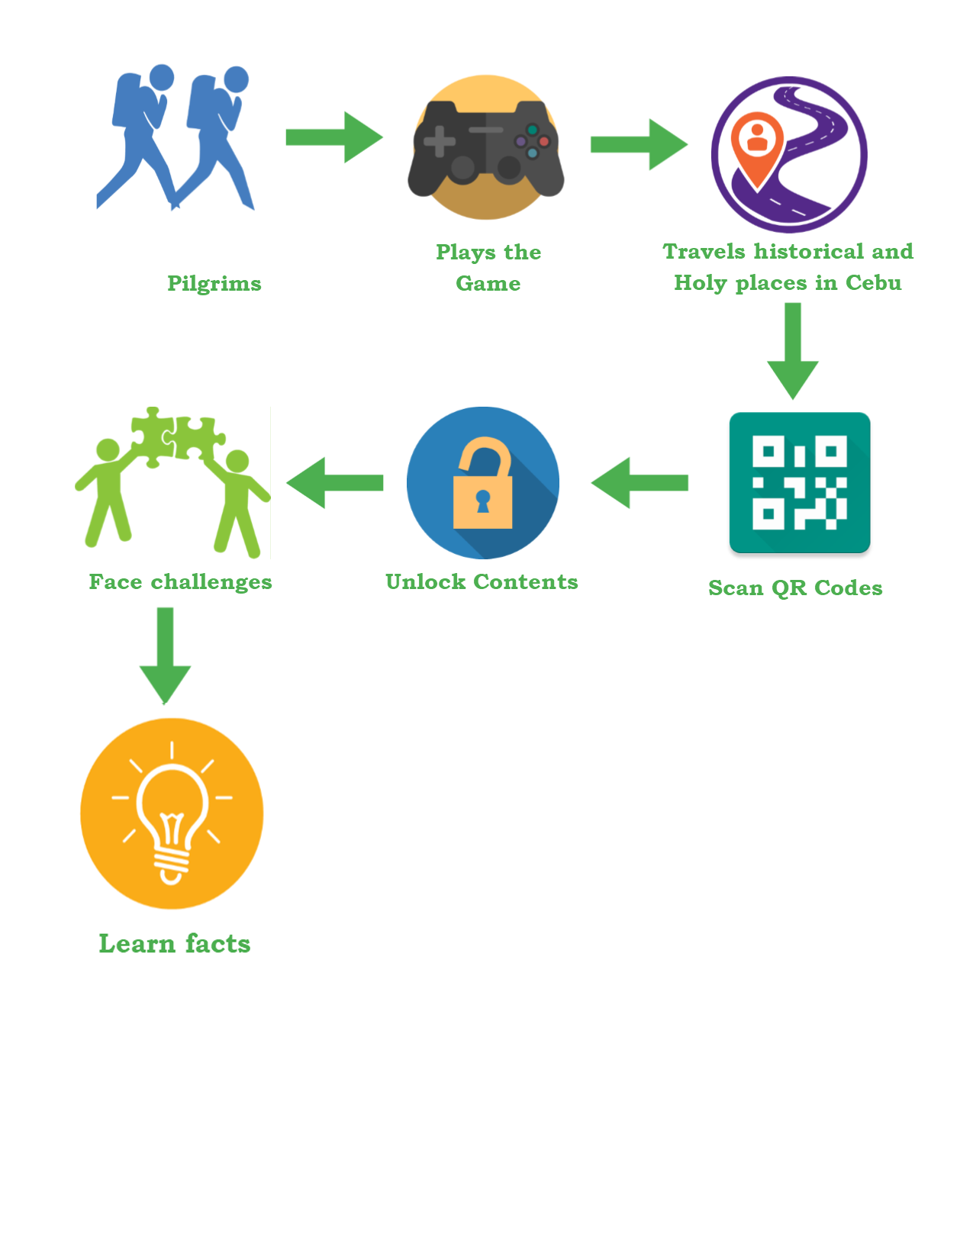

**4.2 Analysis and Design**

The application catered to one person at a time, which is the player. The player has an option to pick several game modes that the application provided, with the main attraction being the RPG. He has the option to start a new game or pick up where he left off by loading a save file. Upon starting the game, the players get introduced with a simple plot to set up the atmosphere, and can only progress if they go to a specific location and defeat the enemies lurking around that area.

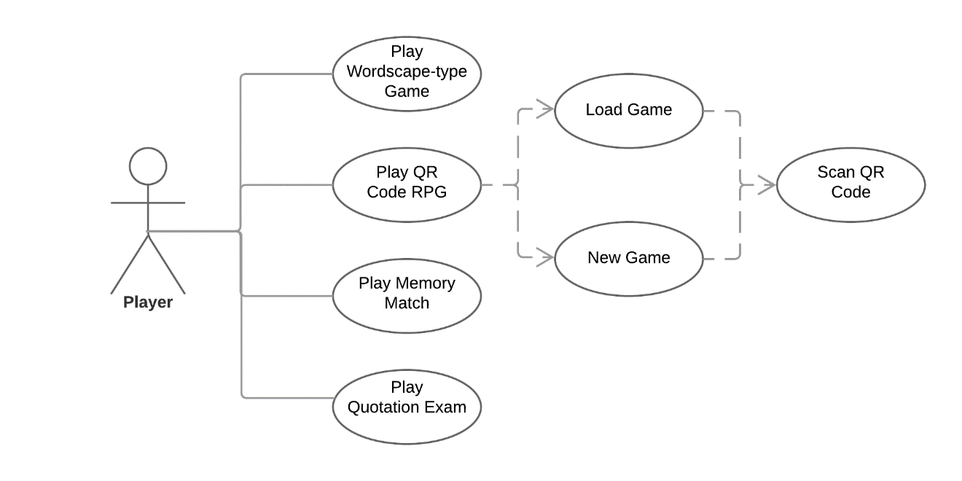

*Figure 2*: Use Case Diagram

**4.3 Development Method**

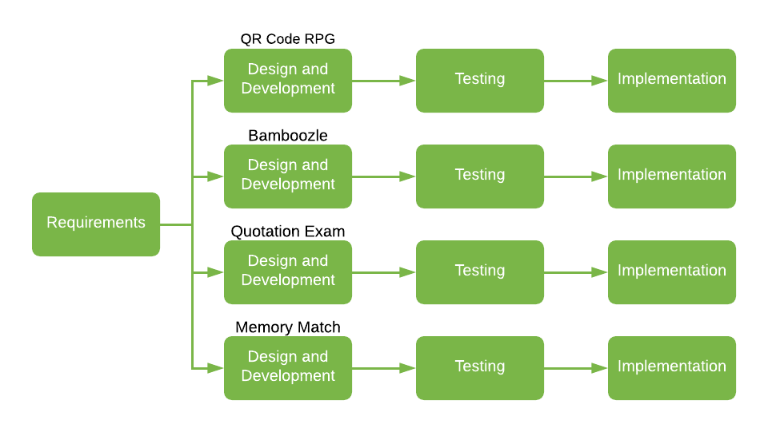

*Figure 3*: Incremental Model

The researchers used the incremental model in their system model development. First, they decided what specification and modules they’d need to implement to the system. After all the brainstorms and documentations were conducted, the researchers started to develop the first module, which is the QR code RPG, out of the four planned modules of the system. After the 1st module was done, the researchers and the adviser decided if the module was satisfactory, otherwise, the researchers made revisions or improve it.

After the first module had been implemented and verified, the researchers then started working at the second module. This process was repeated until all of the modules are implemented and verified.

**4.4 Development Approach**

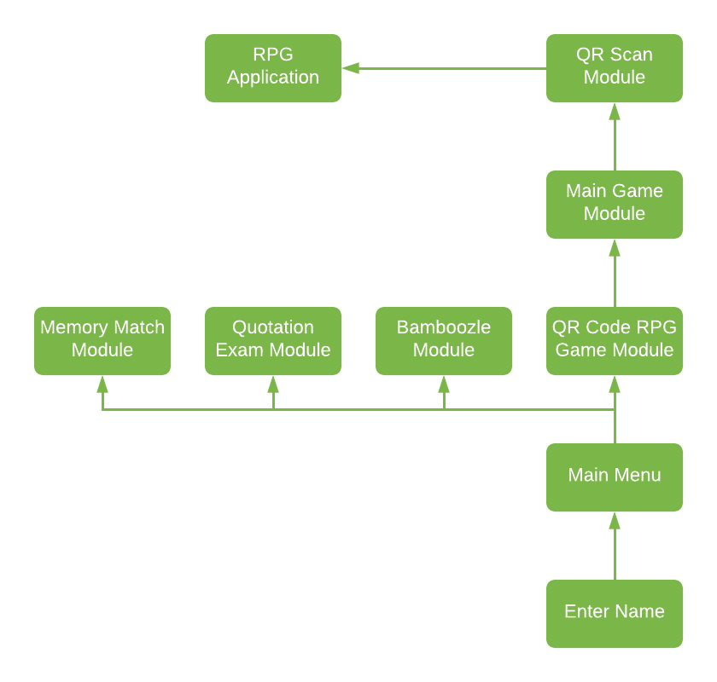

*Figure 4*: Bottom-up Approach

The main reason why the researchers used the Bottom-up approach was that this is not a very huge project that needs to borrow money from a large organization. It is a project where the people have a lot to say about it and is planned and controlled by local communities to help their local area.

**4.5 Software Development Tools**

These are the tools necessary for mobile application development. All of these softwares, except Adobe Photoshop and Microsoft PowerPoint, which is optional, are free to use and are very flexible for their development.

Table 2

*Software Development Tools*

|  |  |  |  |
| --- | --- | --- | --- |
| **Software** | **Version** | **Source** | **Use** |
| **Unity 3D** | 2018.1.0f2 | https://unity3d.com/ | A game engine used to render 2D graphics. |
| **Adobe Photoshop** | 2016 | https://www.adobe.com/ | A photo manipulation tool to edit and enhance assets for the game. |
| **Paint Tool SAI** | 2016 | https://www.systemax.jp/en/sai/ | Painting software used to draw the assets of the game. |
| **Microsoft PowerPoint** | 2016 | https://office.live.com/start/PowerPoint.aspx | Software used to present the materials in an orderly manner. |

**4.6 Project Management**

These are the development schedule and timeline for the mobile application.

**4.6.1 Schedule and Timeline**

Table 3

*Gantt Chart of Activities, 3rd and 1st Semester (SY 2017-2018)*

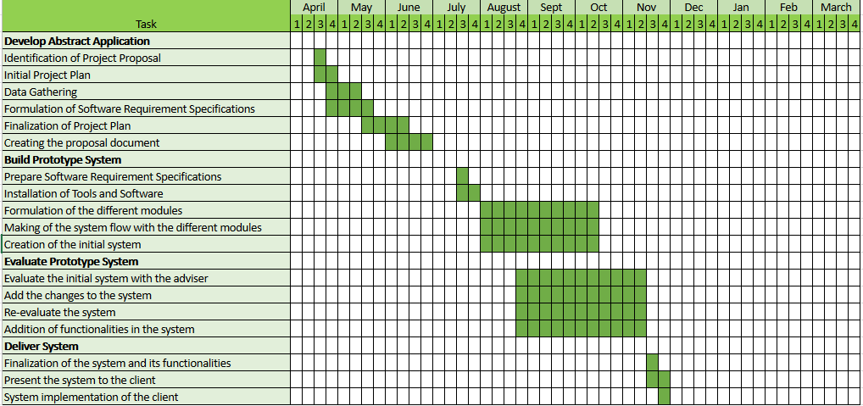

**4.6.2 Responsibilities**

Table 4

*Responsibilities*

|  |  |  |
| --- | --- | --- |
| **Name** | **Role** | **Purpose** |
| Penuel B. Calle | Back-end programmer | Lead programmer |
| Kitt Michael Edward Yap | Front-end programmer | In charge of art assets of the game. |
| Nicolas Andre Ferraren | Front-endProgrammer | Writer and game designer. |
| Bryan Bispo | Back-endProgrammer | Focuses on mini-games |

**4.6.3 Budget and Cost Management**

Table 5

*Budget and Costs*

|  |  |
| --- | --- |
| **Cost Description** | **Cost** |
| Printing | ₱ 1,000.00 |
| Laptop: Lenovo Legion Y720 | ₱ 80,000.00 |
| Graphics Tablet | ₱ 6,000.00 |
| Mouse | ₱ 1,000.00 |
| Electricity Bill | ₱ 10,000.00 |
| **Total** | **₱ 98,000.00** |

**4.7 Verification, Validation, and Testing**

The researchers had decided to implement Black Box Testing on the application. Black Box Testing was when the testers had little to no information about the design or implementation of the application in question. Basically, being sent blind and no expectations to find out things such as ease of use: missing functions, missing user interface, performance issues, and vital things such as errors. Black Box Testing will be the researchers’ main verification. It required at least twenty people to make sure that the validation results are varied within the sample size.

The researches had decided to have User Acceptance Testing. With it, the goal was to see if the users have a great time with the application or have easy time accessing the user interface and going about the process of the application. User Acceptance Testing was the researchers’ main validation. Out of 15,000 delegates in National Youth Day, the expected number of users are about 100, with the researchers used the data to improve the system itself.

Testing was done separately, both verification and validation being the important key factors in the success of testing, to see any mishaps or trends that to be noted from verification and validation. As stated above, this data was critical in understanding the needs of the users.

**CHAPTER 5**

**RESULTS AND ANALYSIS**

This chapter covers the different steps taken to measure the users’ acceptability of the system, the functionality of the system, and the results.

**5.1 Systems Capability**

* The application can open the camera and scan the QR code.
* The application gives bite-sized information about Cebu’s history.
* The application can play three mini-games. Two of which are related to history.

**5.2 Major Modules**

The proposed mobile application has the following major modules:

* Main Game – contains the following functions:
* QR Code – opens the camera to scan the QR code
* Dialogue – tells the story contained in the application
* Battle – can attack, heal, and answer the questionnaires that pop on the screen to defeat enemies
* Bamboozle – contains the following functions:
* Difficulty Mode – Allows the player to choose the difficulty.
* Level selector – Allows the player to choose the level after selecting a difficulty.
* Bamboozle Game – Shows a crossword puzzle with the given letters for the users to solve.
* Memory Match – contains the following functions:
* Difficulty Mode – Allows the player to choose the difficulty.
* Level selector – Allows the player to choose the level after selecting a difficulty.
* Memory Match Game – Shows a find-pair game with set amount of cards to flip and find a match.
* Quotation Exam – contains the following functions:
* Difficulty Mode – Allows the player to choose the difficulty.
* Level selector – Allows the player to choose the level after selecting a difficulty.
* Quotation Exam Game – Shows a quote from a famous Philippine related individual for the users to guess who quoted it.

**5.3 Testing and Validation of the System**

The application was tested on October 30, 2018 to November 8, 2018 by 10 people to evaluate the acceptability for target users.

Table 6

*Validation Analysis Table*

|  |  |
| --- | --- |
| Criteria | Users |
| 1. Usability | 3.6 |
| 2. User Friendliness | 3.67 |
| 3. Functionality | 3.67 |
| 4. Efficiency | 3.66 |

Average Score Implementation:

4.1 – 5.0 = Very Acceptable

3.1 – 4.0 = Acceptable

2.1 – 3.0 = Moderately Acceptable

1.0 – 2.0 = Not Acceptable

Average Score Calculation:

$$\frac{\left(Usability+User Friendliness+Functionality+Efficiency\right)}{4}=AVG$$

Average Score: 3.65

Based on the given data, the average rating of the target users gave is an average score of 3.65 which is an Acceptable score based on the given criteria.

See Appendix E for Detailed User Acceptance Testing

**5.4 Testing and Verification of the System**

A Black Box Test was conducted on 10 people who have experience in application development.

The decision for acceptability was defined according to the following rules:

* Acceptable – The test case was concluded as a “Pass” status to indicate that the actual result meets the expected result.
* Not Acceptable – The test case was concluded as a “Fail” status to indicate that the actual result does not meet the expected result.

The results of the test’s success will be determined by the following:

Table 7

*Verification Analysis Table*

|  |  |  |
| --- | --- | --- |
| Modules | Success Rate | Assessment |
| Menu | 99.23% | Very Acceptable |
| Main Game | 99.33% | Very Acceptable |
| Bamboozle | 98.75% | Very Acceptable |
| Memory Match | 96.67% | Very Acceptable |
| Quotation | 100% | Very Acceptable |

Average Score Implementation:

91% – 100% = Very Acceptable

81% – 90% = Acceptable

71% – 80% = Moderately Acceptable

61% – 70% = Not Acceptable

Average Score Calculation:

$$\frac{\left(Menu+Main Game+Bamboozle+Memory Match+Quotation\right)}{5}=AVG$$

Average Score: 98.80

Based on the given data, the average rating of the testers gave is an average score of 98.80 which is a Very Acceptable score based on the given criteria.

See Appendix D for Detailed and Sample Test Cases (Black Box Testing)

**CHAPTER 6**

**CONCLUSION AND RECOMMENDATION**

**6.1 Summary of Results**

The User Acceptance Test yielded an average score of 3.65 out of 5. This is determined by taking the average scores of all criteria to give them the actual acceptability score. The score translates to Acceptable according to the determined criteria.

**6.2 Conclusion**

In this document, it was shown that the researchers were able to develop a mobile game application in fulfillment to the system requirements specifications that were given. After conducting the tests, they have recognized that the application is Acceptable for target users.

Given that smartphones are becoming more common and E-learning is starting to become the standard curriculum for some schools, it is given that learning without being restricted to location and time is an important aspect that the education industry needs to evolve.

**6.3 Future Work**

The application as of now, requires a smartphone with a relatively strong specifications, and the file size of the game is too much for what it does. The reason behind this is because of several high quality pictures that were left uncompressed and the loading times are often long.

**BIBLIOGRAPHY**

**Journals**

Nichols, M. (2007). "E-learning in context"

Squire, K. D. (2002). [“Video Games and Education: Designing Learning Systems](https://pdfs.semanticscholar.org/4f11/f96ec67d2f29e511206a80e865e8584fcfc3.pdf)

for an Interactive Age.”

Rosenberg, L.B. (1992). "The Use of Virtual Fixtures As Perceptual Overlays to

Enhance Operator Performance in Remote Environments". Technical

Report AL-TR-0089, USAF Armstrong Laboratory, Wright-Patterson AFB OH, 1992.

**Web Articles**

Advantages of the Unity Game Engine – The Ultimate Tool for Game Development. (n.d.). Retrieved from https://blog.udemy.com/unity-game-engine/

Author, G. (2018). Duolingo Review: The Quick, Easy and Free Way to Learn A Language - Fluent in 3 months - Language Hacking and Travel Tips. Retrieved from https://www.fluentin3months.com/duolingo/

Brothers, S. (2007). Game-based e-learning: The next level of staff training. Retrieved from <https://www.iadvanceseniorcare.com/article/game-based-e-learning-next-level-staff-training>

Final Fantasy. (2018). Retrieved from https://en.wikipedia.org/wiki/Final_Fantasy

Four ways smartphones are changing the world for the better. (2016, July 22). Retrieved from https://www.androidauthority.com/four-ways-smartphones-changing-world-better-685356/

Obringer, L. A. (2001, October 01). How E-learning Works. Retrieved from <https://people.howstuffworks.com/elearning1.htm>

Persona 5. (2018). Retrieved from https://en.wikipedia.org/wiki/Persona_5

Pokémon Go. (2018, May 03). Retrieved from https://en.wikipedia.org/wiki/Pokémon_Go

Role-playing video game. (2018, May 04). Retrieved from https://en.wikipedia.org/wiki/Role-playing_video_game

Stokes, P. J. (2018, March 01). How E-Learning Will Transform Education. Retrieved from <https://www.edweek.org/ew/articles/2000/09/13/02stokes.h20.html>

Team, E. (2018). What is GBL (Game-Based Learning)?. Retrieved from http://edtechreview.in/dictionary/298-what-is-game-based-learning

Times, H. U. (2016, September 19). Pokémon GO Tricks To Attract And Catch Pokémon: PokéStop Lure Module vs. Incense. Retrieved from http://www.techtimes.com/articles/170319/20160718/pokémon-go-tricks-to-attract-and-catch-pokémon-pokéstop-lure-module-vs-incense.htm

Video games in education. (2018, April 26). Retrieved from https://en.wikipedia.org/wiki/Video_games_in_education

What is E-Learning? (n.d.). Retrieved from https://community.articulate.com/series/getting-started/articles/what-is-e-learning

[. (n.d.). How Smartphones Revolutionized Society in Less than a Decade. Retrieved from <http://www.govtech.com/products/How-Smartphones-Revolutionized-Society-in-Less-than-a-Decade.html>

**APPENDIX A**  
**TRANSMITTAL LETTER**

June 4, 2018

Ms. Quitten Cacanog II

National Youth Day Staff Member

Dear Ms. Cacanog,

Greetings!

May we request from you the permission to gather information from you and the National Youth Day staff for our research study titled, “Pedro’s Journey: A Mobile Game Application”.

The above research study is a requirement for the completion of the degree in Bachelor of Science in Information Technology in the University of San Carlos. I am confident that the result of the study will be useful, helpful, and fruitful in the betterment of the overall experience of the participants of National Youth Day.

Thank you very much, and I am looking for a positive response.

Respectfully yours,

Bryan Bispo

Penuel Calle

Nicolas Ferraren

Kitt Yap

BSIT Students, University of San Carlos

Endorsed by:

Angie M. Ceniza, PhD

Capstone Adviser

Approved by:

Quitten Cacanog II

National Youth Day Staff Member

**APPENDIX B**  
**INTERVIEW GUIDE**

* What are the list of possible locations for National Youth Day?  
  __________________________________________________________
* What is the demographic for this system?  
  __________________________________________________________
* What are the requirements needed for this system to run on a smartphone?  
  __________________________________________________________
* When will the National Youth Day be held?  
  __________________________________________________________
* How many people are to be expected to join this event?  
  __________________________________________________________
* Is it possible that in one location it has more than one QR code or just one QR code to unlock a specific location?  
  __________________________________________________________
* Is there a system, similar to this, that was developed for National Youth Day?  
  __________________________________________________________

**APPENDIX C**

**SOFTWARE REQUIREMENTS SPECIFICATION**

**Pedro’s Journey: A Mobile Game Application**

By:

BRYAN Z. BISPO

PENUEL B. CALLE

NICOLAS ANDRE P. FERRAREN

KITT MICHAEL EDWARD P. YAP

ANGIE M. CENIZA, PhD

Faculty Adviser

**Introduction/Rationale of the Study**

A mobile application is an app for mobile devices. It provides limited functionality such as a simple game, a calculator, or mobile web browsing but that was due to the limited hardware resources of the early versions of mobile devices. Now, mobile applications have become more flexible because of mobile devices continuing to evolve every year and due to the continuous evolution, people can now easily access information and gain knowledge with the rapid technological evolution.

Learning history can be fun or tedious. Some people tend to get bored and some find it interesting. One of the most fun and engaging way of learning is through playing a game because through a game, people will be entertained and at the same time learn something out of it.

The main goal of this e-learning game application is to teach Pilgrims that are participating National Youth Day the history of Cebu through an educational gaming platform.

**System Description**

Pedro’s Journey is a game application where the user plays the role of a time traveler going back in time to engage in historical events of certain landmarks, thus re-living the vast history of Cebu Province’s historic and religious places. The proponent decided that in order to make the game more immersive and involved with the real world, the main game requires them to go to literally go to certain historical and religious places to access the game’s contents and enhance their learning experience.

Types of User:

**Player** - can access the entirety of the game

## **Design Model**

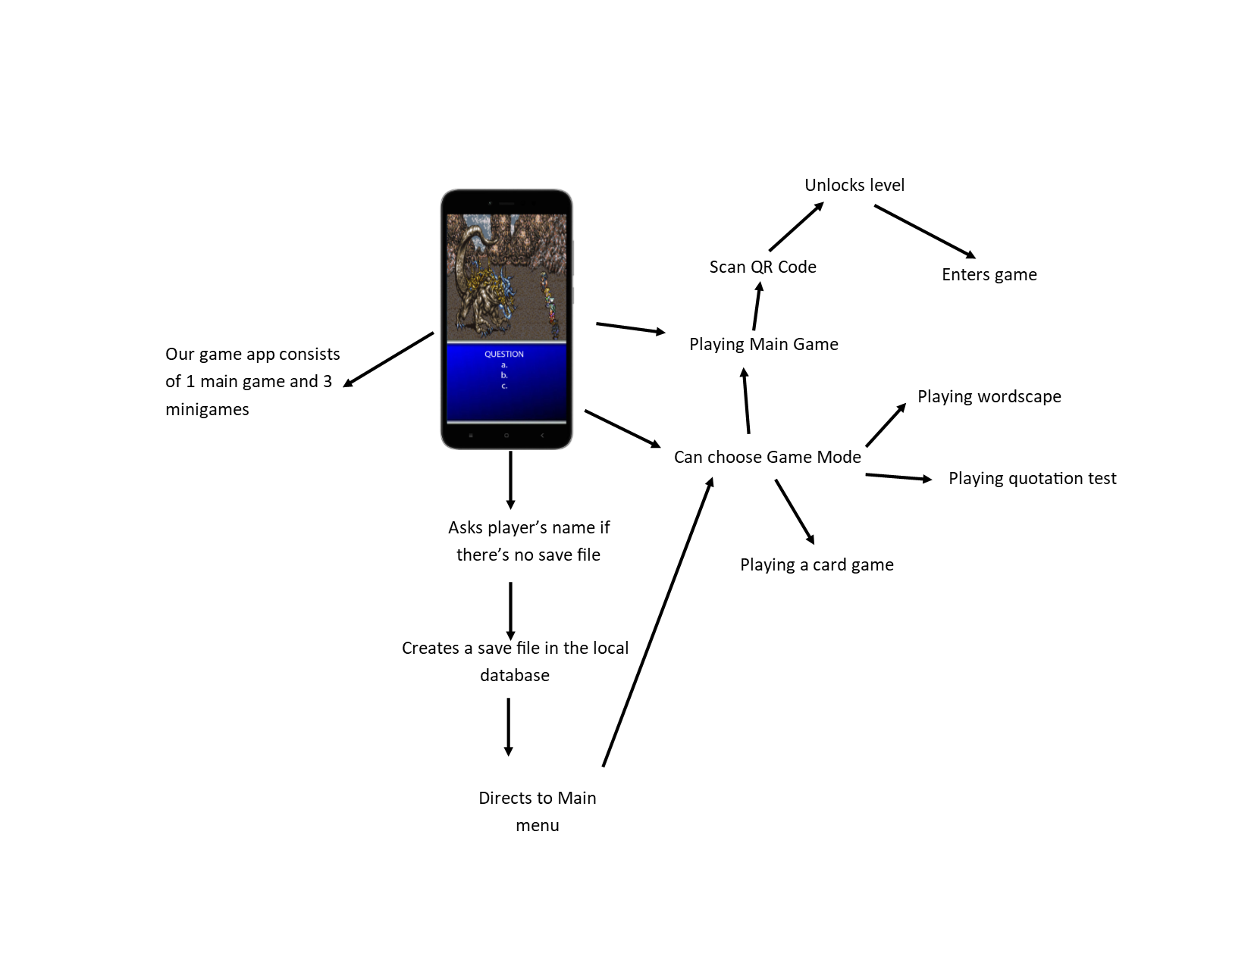

The game application implements the core gameplay of common role-playing games. It will let the user start the game application to familiarize themselves with the game’s goal and story. Afterwards, the game lets the user engage to historical events, making them the part of the history. It involves engaging into turn based battles where the outcome is based on how knowledgeable the users are related in that specific event.

***Gameplay***

*QR Code RPG*

The main game of the application is a turn-based, story-driven, strategic RPG that centers around the historical and religious events that have happened in Cebu. The player is first treated to a prologue chapter that acts as a tutorial for the game that teaches them the core mechanics of the game as well as gives them a taste of what the game is all about and what the game has to offer. Afterwards, the player is shown the entire map of Cebu with icons of specific locations all over it. As the player chooses a location, they are prompted to bring up their camera so they can scan QR codes.

This game needs to scan QR codes to unlock the content of each place in the given map. The QR codes will be located in those specific places in the real world, so the player literally has to travel to that location in real life to be able to scan it. Each place is a level, where you experience and play through the history of that specific place in Cebu in the form of story and dialogue scenes. Since this is an RPG, the player gets to participate in battle where the player has to answer multiple choice questions related to the history of that place correctly for them to be able to launch an “attack” against the opponent. If the player gets the questions wrong, then the opponent gets to attack the player. If the player’s life points reach 0, he gets a “game over” and has to try again. Once they get all the questions right or get the opponent’s life points to 0, the player wins, levels up, and gets to progress through the game. Once the player has finished all the levels, the final level appears which concludes the player character’s overall story arc.

*Bamboozle*

One of the three minigames in the application. In this minigame, the player holds and slides a given letter to form a word. Once they successfully form a word that fits in the crossword, they get points depending on the length of the word. The player has a time limit and if the time limit has passed, then the player loses the game. If the player wins, the game will move to the next level. This will have 3 levels of difficulties and each difficulty has three levels.

*Quotation Exam*

One of the three minigames in the application. It’s a multiple-choice examination game where the player is given an incomplete quote from a specific saint and has to complete the quote by answering the correct choice. The player is given three chances. If the player manages to answer all correctly, the player wins. If the player gets three wrong answers, then the player gets a “game over”, having to start all over again from the beginning. This contains 3 levels of difficulty and each difficulty has three levels, which is randomly generated.

*Memory Match*

One of the three minigames in the application. It’s a card matching game which has a “saint” card which has the face and name of the saint. The cards are placed face down and the player can only lift two cards up at once. If the cards lifted don’t match, then they are faced back down. If the cards match, then they disappear from the field. Once all cards have disappeared, the player wins. The player loses if the timer reaches zero. This will have 3 levels of difficulties and each difficulty has three levels.

**System Flow/Development Process**

The game application starts up with a main menu that contains up to three game modes to choose from, the main attraction being the QR code RPG. When the user picks the QR code RPG, the game prompts the player to input their name when it’s their first time playing, otherwise, the game will pick up where the player left off. It revolves around the history of Cebu where the player will progress through the story that’s related to it, and engage into battles against a random or a familiar enemy. In order to progress, the player has to go to certain locations where they will find a QR code to scan from their smartphones.

In case the user is done with the QR code RPG or is not interested, the game has several minigames to choose from, where the content is still related to the history of Cebu.

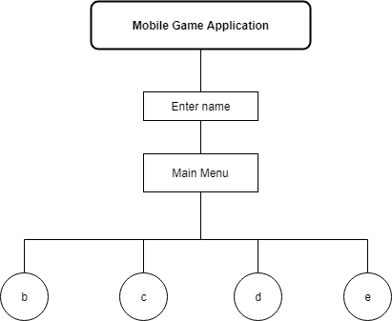

1. **Main Menu Module** - it enables to let the players to choose whether to play the main game or the mini games in the menu.
2. **QR Code RPG** - it enables the player to scan the QR Code and unlock the level and play.

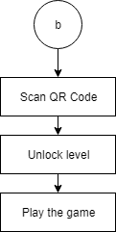

**C. Bamboozle** - it enables the player to play the minigame Bamboozle.

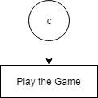

**D. Quotation Exam** - it enables the player to play the minigame that test the player’s knowledge of the quotes of famous people from the history of Cebu.

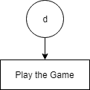

**E. Memory Match** - it enables the player to play the mini card game.

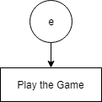

**Use Case Diagram**

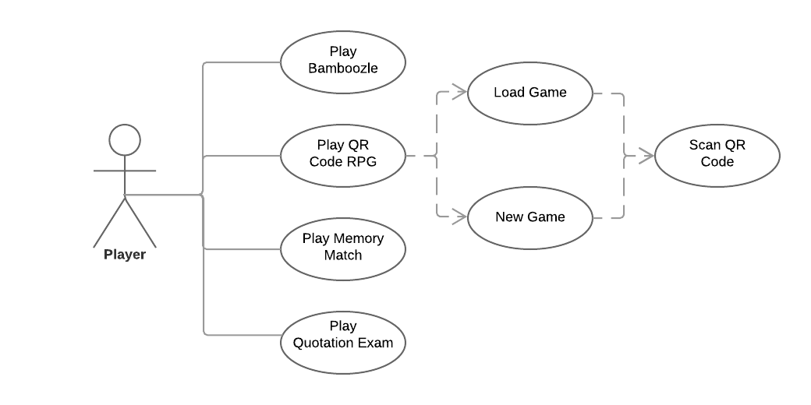

**Wireframe of the Mobile Application**

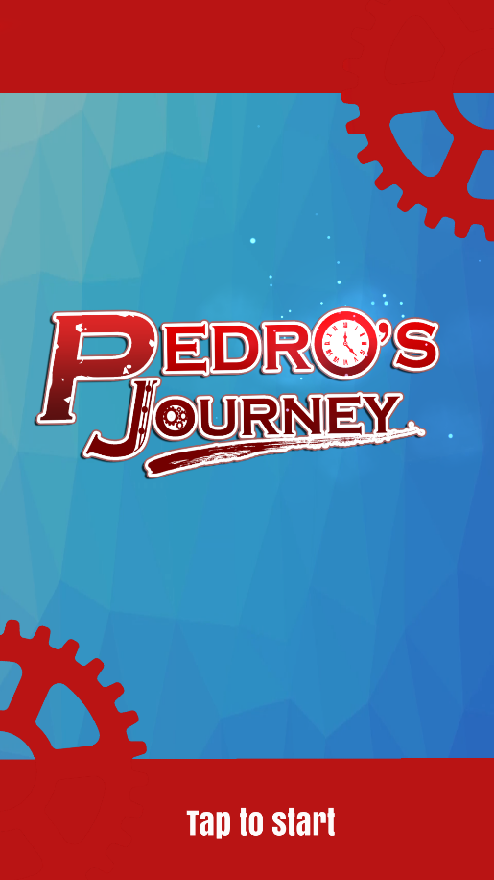

**1**

**1.Tap to Start –** It enables the user to start the game and proceed to enter your name menu and then to mode select menu.

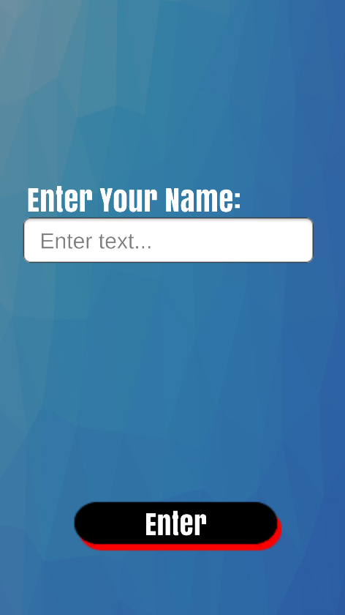

**2**

**3**

**2. Enter your name text field -** It enables users to input the name they want for the Main Character.

**3. Enter Button** - It enables the user to proceed and confirm the name being inputted

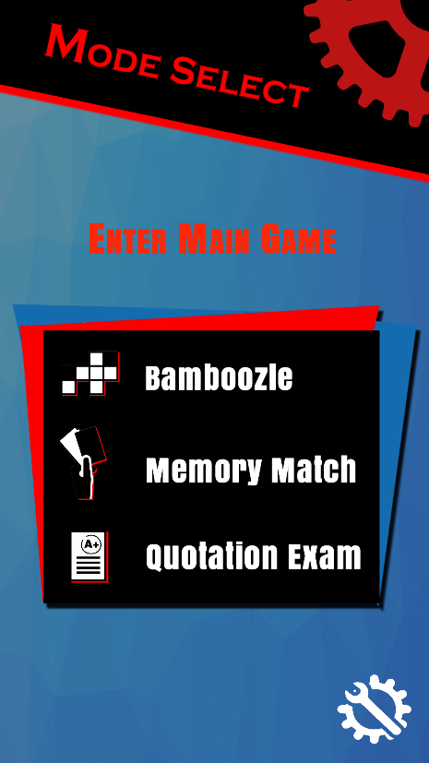

**8**

**7**

**6**

**5**

**4**

**4. Enter Main Game button** - It enables the user to enter to the main game

**5. Bamboozle button** - It enables the user to play the minigame Bamboozle.

**6. Quotation Exam button** - it enables the user to play the minigame that test the player’s knowledge of the quotations of famous people from the history of Cebu.

**7. Memory Math button** - It enables the user to play the mini card game.

**8. Options button** - It enables the user to proceed to the Options menu.

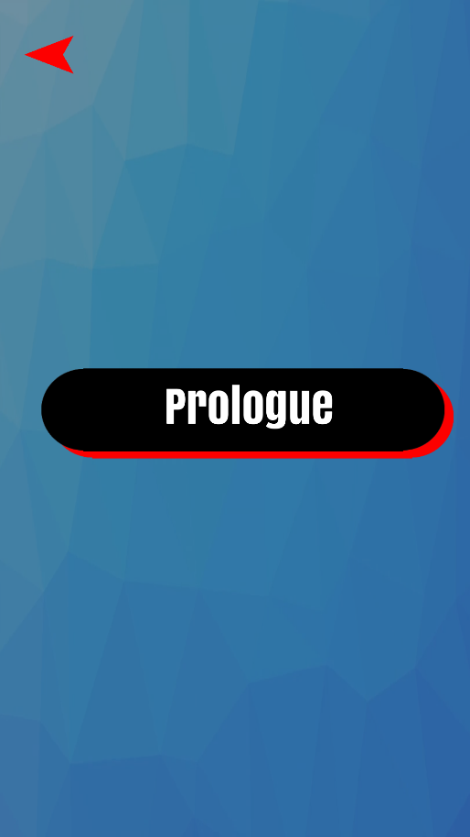

**10**

**9**

**9. Prologue button -** It enables the user to play the prologue of the main game.

**10. Back button -** It enables the user to go back to the previous screen.

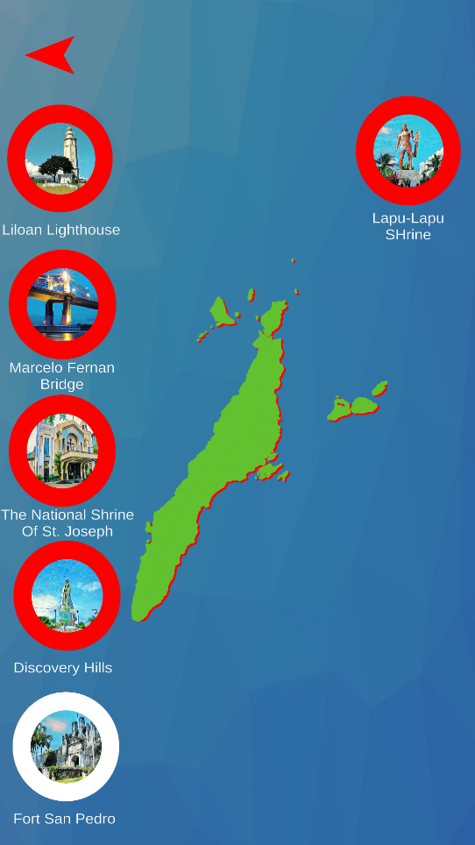

**12**

**11**

**11. Chapter or Location Button -** It enables the user to play a chapter of the main game.

**12. Back button -** It enables the user to go back to the previous screen.

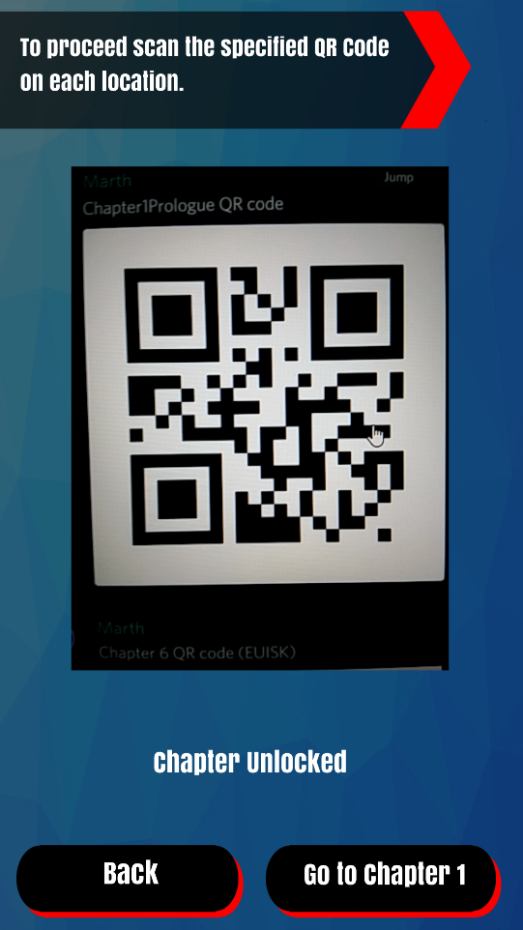

**15**

**14**

**13**

**13. QR Code Camera Scanner -** It enables the user to scan the QR code of the respective chapter.

**14. Go to Chapter button -** It enables the user to proceed to the respective chapter and play.

**15. Back button -** It enables the user to go back to the previous screen.

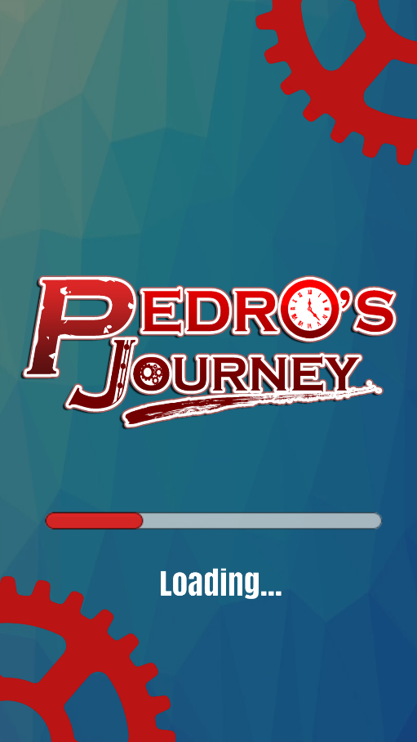

**16**

**16. Loading bar -** It enables the user to see how much longer will the next screen load.

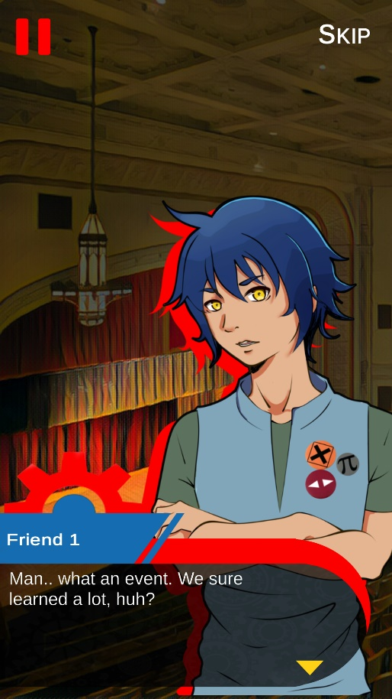

**19**

**18**

**17**

**17. Dialogue box -** It enables the user to read the dialogue and tap to proceed.

**18. Pause button -** It enables the user to pause the game.

**19. Skip button -** It enables the user to skip the dialogue scenes and proceed to the battle gameplay.

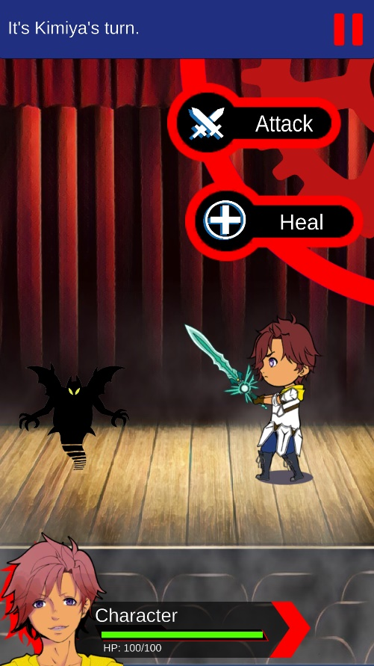

**23**

**22**

**21**

**20**

**8**

**20. Attack button** - It enables the user to damage the enemy.

**21. Heal button -** It enables the user to heal his/her character.

**22. Pause Button -** It enables the user to pause the game.

**23. Health/HP Bar -** It enables the user to see the remaining health left.

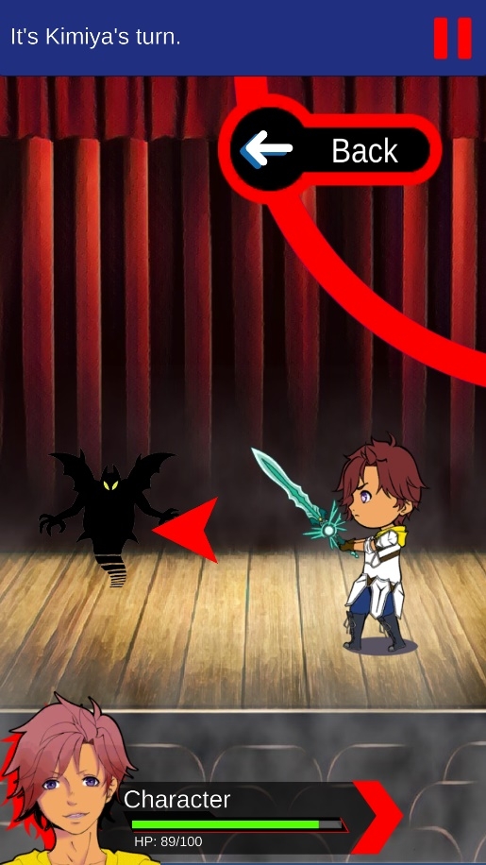

**27**

**26**

**25**

**24**

**24. Back button -** It enables the user to go back selecting the move he/she will use for his/her turn whether to attack or heal.

**25. Arrow button -** It enables the user to select the enemy to attack on.

**26. Pause button -** It enables the user to pause the game.

**27. Health/HP bar -** It enables the user to see the remaining health left.

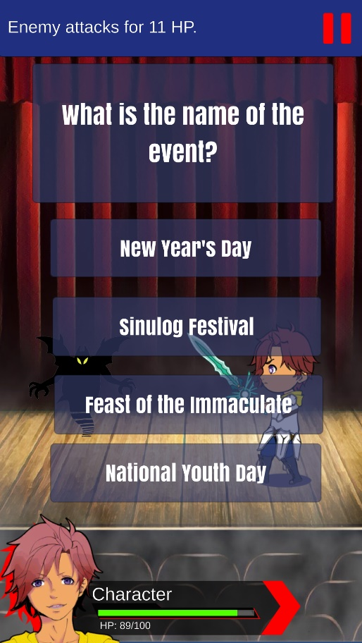

**29**

**28**

**28. Questionnaire Box -** It enables the user to see the questions given.

**29. Choice buttons -** It enables the user to select the answer of his/her choice.

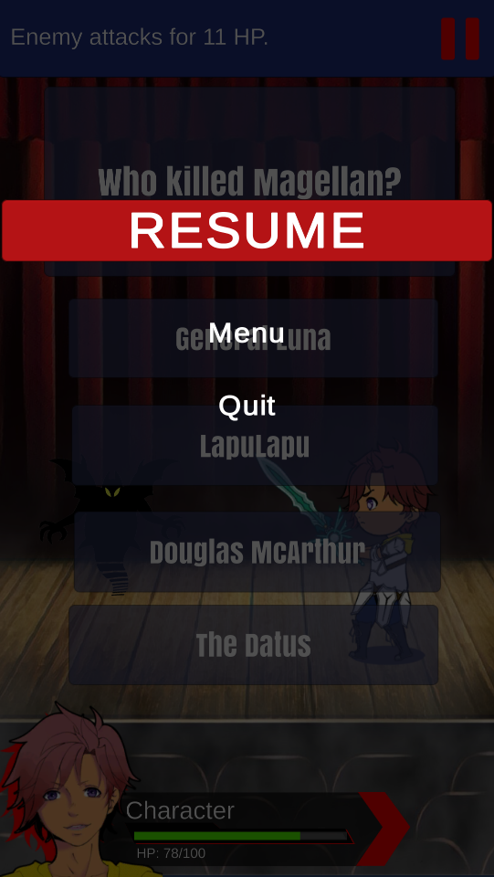

**32**

**31**

**30**

**30. Resume button -** It enables the user to resume playing the game.

**31. Menu button -** It enables the user to go back selecting from the Map menu.

**32. Quit button -** It enables the user to quit the game.

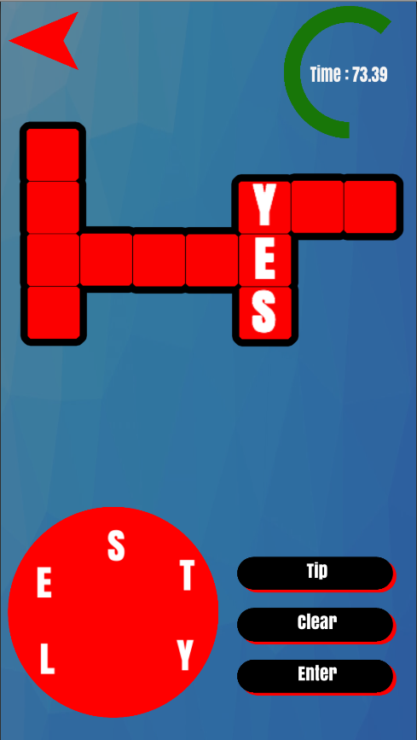

**37**

**38**

**34**

**33**

**36**

**35**

**33. Tap a letter buttons** - It enables the user to tap the letter and form a word.

**34. Tip button -** It enables the user to see a hint in a form of an image.

**35. Enter button-** It enables the user to enter the word and check if it’s right or wrong.

**36. Clear button -** It enables the user to clear the letters selected.

**37. Back button -** It enables the user to go back to the previous screen.

**38. Timer -** It enables the user to see the amount of time left.

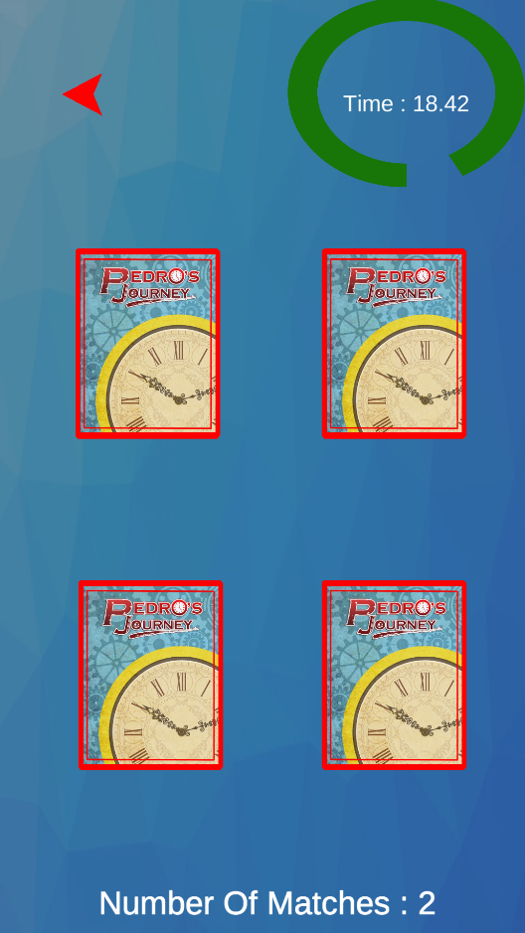

**39**

**41**

**40**

**39. Tap the card -** It enables the user to tap the card and flip the card.

**40. Back Button -** It enables the user to go back to the previous screen.

**41. Timer -** It enables the user to see the amount of time left.

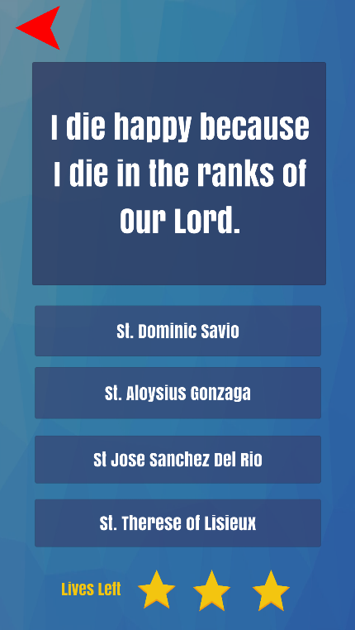

**43**

**44**

**42**

**45**

**42. Quotation Box** - It enables the user to read and identify the owner of the given quotation.

**43. Choice buttons -** It enables the user to select the answer of his/her choice.

**44. Lives Left -** It enables the user to see his/her lives left

**45. Back Button -** It enables the user to go back to the previous screen.

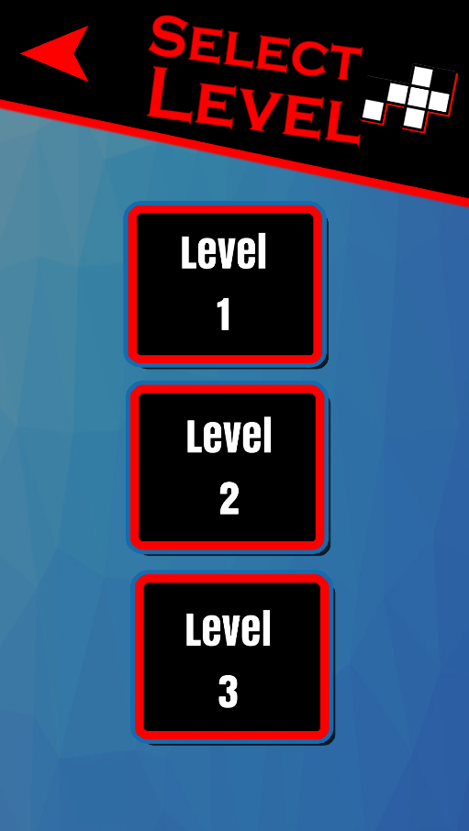

**47**

**46**

**46. Back button -** It enables the user to go back to the previous screen.

**47. Level button -** it enables the user to play the level.

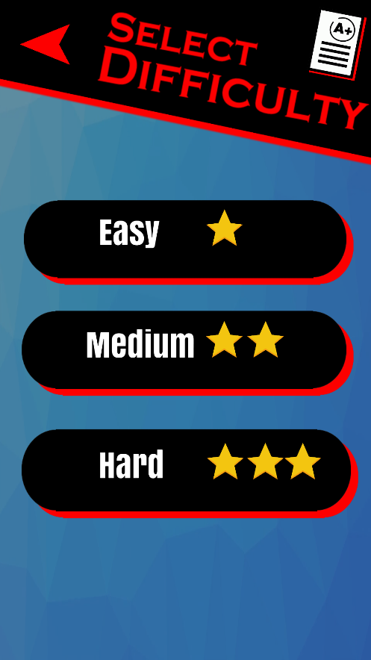

**49**

**48**

**48. Back Button ­-** It enables the user to go traverse back to the previous page

**49. Difficulty Buttons** **-** It enables the user to choose the difficulty of the game.

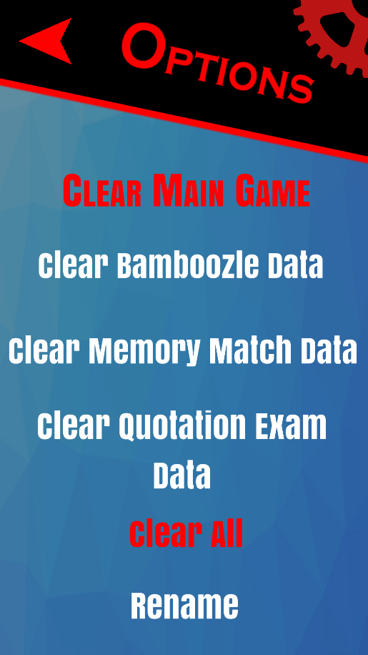

**55**

**54**

**53**

**52**

**51**

**50**

**50. Clear main game button -** It enables the user to clear the save data of the main game.

**51. Clear Bamboozle data button -** It enables the user to clear the save data of the bamboozle minigame.

**52. Clear Memory Match data button -** It enables the user to clear the save data of the memory match minigame.

**53. Clear Quotation Exam data button -** It enables the user to clear the save data of the quotation exam minigame.

**54. Clear all button -** It enables the user to clear all the save data of the app.

**55. Rename button -** It enables the user to rename the main character of the main game.

**APPENDIX F**

**BLACK BOX TEST CASES**

**Black Box Test Cases for the Main Menus**

|  |  |
| --- | --- |
| USE_CASE_NO | USE_CASE_01_START |
| Description | Start Screen |
| Test Case No. | Description | Test Procedure | Expected Results | Actual Results | Status |
| TST_No_01_01 | Direct to the Enter Name screen | 1.)  Press the Start button | Displays Enter Name screen |  |  |

|  |  |
| --- | --- |
| USE_CASE_NO | USE_CASE_02_NAME |
| Description | Enter Name Screen |
| Test Case No. | Description | Test Procedure | Expected Results | Actual Results | Status |
| TST_No_02_01 | Empty Name | 1.)  Press the Enter button | Error Message: “Name should be at least three characters.” |  |  |
| TST_No_02_02 | Correct number of characters used in a Name | 1.)  Type out name  2.)  Press the Enter button | Displays Main Menu Screen |  |  |

|  |  |
| --- | --- |
| USE_CASE_NO | USE_CASE_03_MAIN |
| Description | Main Menu Screen |
| Test Case No. | Description | Test Procedure | Expected Results | Actual Results | Status |
| TST_No_03_01 | Directs to New/Load Game Screen of the Main Game | 1.)  Press the Enter Main Game button (if save file exists) | Displays the New/Load Game screen of the main game |  |  |
| TST_No_03_02 | Directs to the Difficulty Select Screen of the Bamboozle minigame | 1.)  Press the Bamboozle button | Displays the Difficulty Select screen of the Bamboozle mini-game |  |  |
| TST_No_03_03 | Directs to the Difficulty Select Screen of the Memory Match minigame | 1.)  Press the Memory Match button | Displays the Difficulty Select screen of the Memory Match mini-game |  |  |
| TST_No_03_04 | Directs to the Difficulty Select Screen of the Quotation Exam minigame | 1.)  Press the Quotation Exam button | Displays the Difficulty Select screen of the Quotation Exam mini-game |  |  |
| TST_No_03_05 | Directs to the Settings Screen | 1.)  Press the Settings button | Displays the game’s settings |  |  |
| TST_No_03_06 | Sound plays when pressing button | 1.)  Press any button if it plays any sound | A beeping sound plays when a button is pressed |  |  |

|  |  |
| --- | --- |
| USE_CASE_NO | USE_CASE_04_LOAD |
| Description | New/Load Game Screen of Main Game |
| Test Case No. | Description | Test Procedure | Expected Results | Actual Results | Status |
| TST_No_04_01 | Directing back to Main Menu | 1.)  Press the back button | Displays Main Menu screen |  |  |
| TST_No_04_02 | Directing to New Game yes/no prompt | 1.)  Press New Game button | Displays New Game yes/no prompt |  |  |
| TST_No_04_03 | Directing to RPG_MAP game screen | 1.)  Pressing yes in the new game yes/no prompt  OR  1.)  Pressing Load Game  1.)  Pressing “Enter Main Game” on a fresh install or recently cleared data. | Displays RPG_MAP game screen |  |  |

|  |  |
| --- | --- |
| USE_CASE_NO | USE_CASE_05_DIFF |
| Description | Minigames Difficulty Screens |
| Test Case No. | Description | Test Procedure | Expected Results | Actual Results | Status |
| TST_No_05_01 | Directing to Select Level screen | 1.)  Press “Easy”, “Medium”, or “Hard” buttons | Displays Select Level screen for selected difficulty |  |  |
| TST_No_05_02 | Directing back to Main Menu | 1.)  Press the back button | Displays Main Menu Screen |  |  |

|  |  |
| --- | --- |
| USE_CASE_NO | USE_CASE_06_LVL |
| Description | Minigames Select Level Screens |
| Test Case No. | Description | Test Procedure | Expected Results | Actual Results | Status |
| TST_No_06_01 | Directing to “Bamboozle”, “Memory Match”, or “Quotation Exam” minigame screens | 1.)  Press Levels 1, 2, or 3 buttons | Displays “Bamboozle”, “Memory Match”, or “Quotation Exam” minigame screens |  |  |
| TST_No_06_02 | Directing back to Difficulty Select screen | 1.)  Press back button | Displays Difficulty Select Screen |  |  |

|  |  |
| --- | --- |
| USE_CASE_NO | USE_CASE_07_RPG_MAP |
| Description | Enter Name Screen |
| Test Case No. | Description | Test Procedure | Expected Results | Actual Results | Status |
| TST_No_07_01 | Directing to Prologue Chapter dialogue screen | 1.)  Press the Prologue button | Displays Prologue Chapter dialogue scene of main game  through loading screen |  |  |
| TST_No_07_02 | Directing to other chapters’ QR Code screens | 1.)  Press the chapters buttons once prologue chapter is complete | Displays QR Code camera screen |  |  |

|  |  |
| --- | --- |
| USE_CASE_NO | USE_CASE_08_DLG |
| Description | Dialogue Scenes of Main Game chapters |
| Test Case No. | Description | Test Procedure | Expected Results | Actual Results | Status |
| TST_No_08_01 | Directing to pause menu | 1.)  Press the pause button at the top left | Displays pause menu |  |  |
| TST_No_08_02 | Going from one dialogue text to the next | 1.)  Tap dialogue box | Displays the next dialogue text |  |  |
| TST_No_08_03 | Skipping to battle scene | 1.)  Press Skip button at the top right | Displays battle scene |  |  |
| TST_No_08_04 | Directing back to RPG Map Screen | 1.)  Press the pause button at the top left  2.) Press the menu button | Displays RPG MAP screen |  |  |

|  |  |
| --- | --- |
| USE_CASE_NO | USE_CASE_09_BTL |
| Description | Main Game Battle Scenes |
| Test Case No. | Description | Test Procedure | Expected Results | Actual Results | Status |
| TST_No_09_01 | Directing to pause menu | 1.)  Press the pause button at the top left | Displays pause menu |  |  |
| TST_No_09_02 | Directing back to RPG Map screen | 1.)  Press the pause button at the top left  2.) Press the menu button | Displays RPG MAP screen |  |  |
| TST_No_09_03 | Attacking enemy | 1.)  Press the attack button  2.) press the red arrow button | Player character attacks the enemy, and the enemy attacks back |  |  |
| TST_No_09_04 | Cancel attack | 1.)  Press back button after having pressed attack | Cancels the attack and goes back to the “attack” or “heal” options |  |  |
| TST_No_09_05 | If full health/HP | 1.)  Press Heal button | Error message “HP is already full.” |  |  |
| TST_No_09_06 | If health/HP is not full | 1.)  Press Heal button | Heals the health/hp of player character |  |  |
| TST_No_09_07 | If answer to the question is wrong | 1.)  Select an answer | Enemy attacks player |  |  |
| TST_No_09_08 | If answer to the question is correct | 1.)  Select an answer | Directs to “attack” or “heal” options |  |  |

|  |  |
| --- | --- |
| USE_CASE_NO | USE_CASE_10_BBZ |
| Description | Bamboozle Game Scenes |
| Test Case No. | Description | Test Procedure | Expected Results | Actual Results | Status |
| TST_No_10_01 | Directing to the level select screen | 1.)  Press the arrow button | Going back to the level select screen |  |  |
| TST_No_10_02 | Tip Button | 1.)  Press Tip button | Displays a Tip picture for the game |  |  |
| TST_No_10_03 | Enter Button | 1.)  Press Enter button | Enters the answer word of the player and resets the letter circle |  |  |
| TST_No_10_04 | Reset Button | 1.)  Press Reset button | Resets the answer word of the player and resets the letter circle |  |  |
| TST_No_10_05 | Clicking the letter inside the circle | 1.)  Press Letter | Display the letter towards the partial word, and the letter clicked will be gone |  |  |
| TST_No_10_06 | If the answer is correct | 1.)  Press Enter button | Display the correct word to the corresponding boxes |  |  |
| TST_No_10_07 | If the answer is wrong | 1.)  Press Enter button | Resets the letter circle |  |  |
| TST_No_10_08 | Timer is 0 | 1.)  Wait for the timer to set to 0 | Going to the game over screen |  |  |
| TST_No_10_08 | If all the boxes are filled | 1.)  Answer everything within the allocated time | Going to the Win screen |  |  |

|  |  |
| --- | --- |
| USE_CASE_NO | USE_CASE_11_MM |
| Description | Memory Match Game Scenes |
| Test Case No. | Description | Test Procedure | Expected Results | Actual Results | Status |
| TST_No_11_01 | Directing to the level select screen | 1.)  Press the arrow button | Going back to the level select screen |  |  |
| TST_No_11_02 | Click Card - 1 | 1.)  Press Card | Displays a face card picture |  |  |
| TST_No_11_03 | Click Card - 2 | 1.)  Press Card | Display a face card picture |  |  |
| TST_No_11_04 | If Card -1 and Card -2 are the same | 1.)  Press Card | The face cards will be set until the game is lost or won |  |  |
| TST_No_11_05 | If Card -1 and Card -2 are different | 1.)  Press Card r | The face cards will be return to their back face cards |  |  |
| TST_No_11_08 | Timer is 0 | 1.)  Wait for the timer to set to 0 | Going to the game over screen |  |  |
| TST_No_11_08 | If all the cards are faced up | 1.)  Cards are now faced up | Going to the Win screen |  |  |

|  |  |
| --- | --- |
| USE_CASE_NO | USE_CASE_12_QE |
| Description | Quotation Exam Game Scenes |
| Test Case No. | Description | Test Procedure | Expected Results | Actual Results | Status |
| TST_No_12_01 | Directing to the level select screen | 1.)  Press the arrow button | Going back to the level select screen |  |  |
| TST_No_12_02 | If answer to the question is wrong | 1.)  Select an answer | Life will be reduced |  |  |
| TST_No_12_03 | If answer to the question is correct | 1.)  Select an answer | Another question will pop-up |  |  |
| TST_No_12_04 | If Life is equal to 0 |  | Going to the game over screen |  |  |
| TST_No_12_05 | If number of answers correct are equal to number of answers correct to win |  | Going to the Win screen |  |  |

**APPENDIX E**

**USER ACCEPTANCE TESTING**

Good day! We are fourth year students taking up Bachelor of Science in Information Technology in the University of San Carlos. In fulfillment of our final requirement, we would to request your cooperation by answering this short evaluation of our developed application. Please help us gather information by answering the following questions as honestly and accurately as you can. Thank you!

Name (Optional) :___________________________________________

School Name :___________________________________________

Year Level :___________________________________________

Email Address :___________________________________________

Contact Number :___________________________________________

Legend:

1. Never 2- Not Really 3- Sometimes 4- Mostly 5-Always

|  |  |  |
| --- | --- | --- |
| Question | Rating | Comment |
| *Usability* |  |  |
| I often play offline games instead of online games. |  |  |
| I often find the information of the history of Cebu in digital application instead of books. |  |  |
| I often enjoy using digital applications for information instead of reading books. |  |  |
| Digital applications are more reliable on providing information than books. |  |  |
| I'm going to use this application or an application similar to this for educational purposes in the future. |  |  |
| *User Friendliness* |  |  |
| I can easily find the type of game I am looking for. |  |  |
| I can easily navigate through the application’s different screens. |  |  |
| The application’s user interface are easy to understand. |  |  |
| The texts in the application are legible. |  |  |
| The important buttons are easily found in the application. |  |  |
| *Functionality* |  |  |
| The QR Code scan functionality works on specific chapters with the correct QR code. |  |  |
| The QR Code scan functionality does NOT work on specific chapters that are scanned with the wrong QR code. |  |  |
| I can stop and continue playing without worrying about losing my progress. |  |  |
| I feel more confident in knowing the history of Cebu after using this application. |  |  |
| I feel more confident in knowing the religious history of Cebu after using this application. |  |  |
| The application shows relevant information when needed. |  |  |
| *Efficiency* |  |  |
| The mobile application loads or starts quickly. |  |  |
| I never experienced the application crashing while I'm using it. |  |  |
| The mobile application keeps its pace on introducing instructions. |  |  |
| There is enough information or instructions inside the application. |  |  |

Date of Testing: ________________

_____________________

Signature

**CURRICULUM VITAE**

**CONTACT INFORMATION**

**Full Name:** Penuel Bahinting Calle 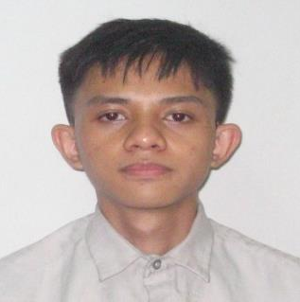

**Current Address:** #46 Echavez St., Brgy Zapatera, Cebu City

**Telephone Number:** 0905 314 9926 / 0947 522 2048

**Email:** p[enuelcalle@gmail.com](mailto:penuelcalle@gmail.com)

**PERSONAL INFORMATION**

Date of Birth: August 6, 1998

Age: 19

Citizenship/Nationality: Filipino

Gender: Male

Marital Status: Single

Number of Children & Age: 0

Language Proficiency: English, Tagalog, Hiligaynon, Cebuano, Japanese

**EDUCATIONAL BACKGROUND**

1. **Educational Level**

Year 2015

School: Destiny Christian Academy - Bacolod

Secondary

Year 2011

School: Destiny Christian Academy - Bacolod

Elementary

**2. Certifications and Accreditations**

1st Honorable Mention - Destiny Christian Academy, 2015

1st Place Honor Roll - Accelerated Christian School, 2009

**TECHNICAL SKILLS**

* **Programming**
* C, C#, Java
* HTML, CSS, PHP, JavaScript
* **Media**
* Adobe Premiere Pro
* GIMP
* Unity 3D
* **Office Applications**
* MS Office
* MS Word
* MS Excel
* MS PowerPoint

**STRENGTHS/TRAITS & SKILLS**

* Hands-on experience
* Able to work within tight schedules
* High degree of initiative

**CAREER OBJECTIVES**

To work on a video game development company that makes games that everybody will enjoy.

**CURRICULUM VITAE**

**CONTACT INFORMATION**

**Full Name:** Bryan Bispo

**Current Address:** Ampalaya Village, Gun-ob Lapu-Lapu City Cebu

**Telephone Number:** 09958362635

**Email:** bryan.bispo13@gmail.com

**PERSONAL INFORMATION**

Date of Birth: April 15, 1999

Age: 19

Citizenship/Nationality: Filipino

Gender: Male

Marital Status: Single

Language Proficiency: English, Filipino, Common Tongue

**EDUCATIONAL BACKGROUND**

1. **Educational Level**

Year 2015

School: Saint Alphonsus Catholic School - Lapu-Lapu City

Secondary

Year 2011

School: Saint Andrew School - Lapu-Lapu City

Elementary

**2. Certifications and Accreditations**

1st Honorable Mention - Saint Andrews School, 2013

**TECHNICAL SKILLS**

* **Programming**
* C, C#, Java - Console Application, Windows Applications
* HTML/CSS/PHP/JavaScript - Website Front-end, Website Back-end, Database
* **Media**
* Adobe Photoshop
* MS Paint
* Adobe CC
* **Office Applications**
* MS Office
* MS Word
* MS Excel
* MS PowerPoint
* **Other skills**
* Writing

**STRENGTHS/TRAITS & SKILLS**

* Able to work within tight schedules
* Perfectionist that will not stop working until the jobs done
* Hands-on Experience
* Imaginative and Open

**CAREER OBJECTIVES**

To work and program on a hardware that will replace almost every interaction on human society. And to create and build a game that will be played for at least 3 generations of human beings.

**CURRICULUM VITAE**

**CONTACT INFORMATION**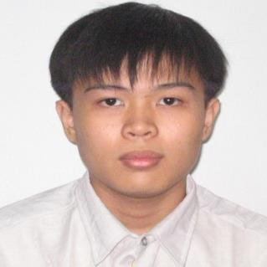

**Full Name:** Kitt Michael Edward P. Yap

**Current Address:** Lower Suran, Bacalso Compound, Quiot, Cebu City, Cebu

**Telephone Number:** 0927 279 1066 / 0933 530 6637

**Email:** kittyap12@gmail.com

**PERSONAL INFORMATION**

Date of Birth: July 29, 1998

Age: 19

Citizenship/Nationality: Filipino

Gender: Male

Marital Status: Single

Number of Children & Age: 0

Language Proficiency: English, Tagalog, Chinese, Cebuano

Computer PMS and Software Skills:

**TECHNICAL SKILLS**

* **Programming**
  + C, Java, C#, HTML, JavaScript, PHP, SQL
* **Media**
  + Adobe Photoshop
  + Unity 3d
  + MS Paint
  + Paint Tool Sai
  + Sony Vegas
* **Office Applications**
  + MS Office
  + MS Word
  + MS Excel
  + MS PowerPoint
* **Others Skills**
  + Drawing

**EDUCATIONAL BACKGROUND**

1. **Educational Level**

Year 2015

School: Cebu Eastern College - Cebu

Secondary

Year 2011

School: Cebu Eastern College - Cebu

Elementary

**2. Certifications and Accreditations**

Top 10 Homeroom Topnotchers Award - Cebu Eastern College, 2011

Bronze Award - Cebu Eastern College, 2015

**STRENGTHS/TRAITS & SKILLS**

* Hands-on experience
* Able to work within tight schedules
* High degree of initiative
* Meticulous

**CAREER OBJECTIVES**

To work under an animation team or as a character designer on a video game development company that makes games that everybody will enjoy.

**CURRICULUM VITAE**

**CONTACT INFORMATION**

**Full Name:** Nicolas Andre Pinote Ferraren 

**Current Address:** 1009 Sangi Rd., Pajo, Lapu-Lapu City, Cebu

**Telephone Number:** 0995 896 5585 / 0932 979 4798

**Email:** hazydreams620@gmail.com

**PERSONAL INFORMATION**

Date of Birth: June 20, 1998

Age: 19

Citizenship/Nationality: Filipino

Gender: Male

Marital Status: Single

Number of Children & Age: 0

Language Proficiency: English, Cebuano, Tagalog, Japanese, Chinese

**EDUCATIONAL BACKGROUND**

1. **Educational Level**

Year 2015

School: Sacred Heart School - Ateneo de Cebu

Secondary

Year 2011

School: Sacred Heart School - Ateneo de Cebu

Elementary

**2. Certifications and Accreditations**

1st Honor Award - Sacred Heart School - Ateneo de Cebu, 2005 - 2008

Loyalty Award - Sacred Heart School - Ateneo de Cebu, 2015

Bronze Award - Sacred Heart School - Ateneo de Cebu, 2015

**TECHNICAL SKILLS**

* **Programming**
* C, C#, Java
* HTML, CSS, PHP, JavaScript
* **Media**
* FL Studio 12
* Adobe Audition CS6
* Audacity
* Sony Vegas Pro
* Melodyne
* **Office Applications**
* MS Office
* MS Word
* MS Excel
* MS PowerPoint

**STRENGTHS/TRAITS & SKILLS**

* Hands-on experience
* Able to work within tight schedules
* High degree of initiative
* Creative
* Open-minded
* Passionate

**CAREER OBJECTIVES**

To work in the video game industry as the lead game designer or music composer in a well-renowned company and make games that I will enjoy making and that everyone else will enjoy. I want to make an impact and leave my mark on this world before I die.